# Michael Chillemi

# 06/28/2023

# CS 590 - Algorithms

# M6.B3: Module 6 Union-Find Structures Application Exercises

Problem 7.5.18

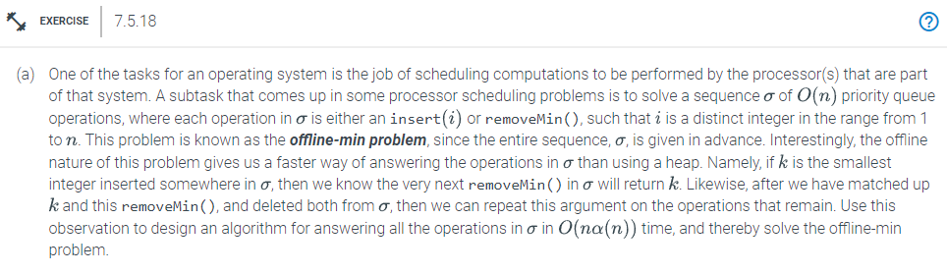

Answer:

We use a disjoint-set forest to implement this approach by placing each element there. Each K set has a pointer to the root of the tree that represents it, and each K set has a pointer to its K set. The linked list contains each and every valid set K. Initialization, which creates the initial sets K in accordance with the sequences, comes before Off-Line-Minimum. We note that there are n elements and that the following disjoint sets procedures exist in order to examine the running time. There will be n times we call MakeSet(). We will need to perform n -1 Union() operations at the most before beginning. We shall execute FindSet() n times. Finally, we'll perform n times of the Link() procedure. Consequently, the total number of m operations is $O(n)$. Running time is totaled to $O(m α(n)) =O(n α(n))$.